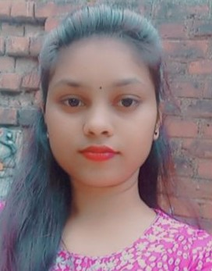

**EDUCATION**

**PROFILE**

**KEERTI VISHWKARMA**

**Web Developer**

I am a Web Developer. I like to learn about new technologies and always seeking for new opportunities. Love to explore myself by learning new concepts and working on them. I am passionate towards front-end and some hands on HTML, CSS, JavaScript. I enjoy making simple, clean and clear websites.

**BUNDELKHAND UNIVERSITY , JHANSI**

B.Sc. | 2017-2020

**GOVERNMENT GIRLS INTER COLLEGE,ORAI**

Class XII, UP BOARD-86% | 2016-2017

Class X, UP BOARD-82% | 2014-2015

**PERSONAL DETAILS**

**WORK EXPERIENCE**

**Date of Birth**

24/06/2000

**Marital Status**

Unmarried

* FRESHER

**SKILLS**

**CONTACT**

* HTML
* CSS
* JAVASCRIPT
* MS OFFICE

391-mail4.png

keertidvcorai@gmail.com

067-phone.png

+91 9005533066

001-home.png

**LANGUAGES**

New Patel Nagar, Orai, Jalaun, U.P.-285001

* Hindi
* English

**HOBBIES**

* Music
* Sketching
* Reading
* Writing